Local History Group
On Wednesday the 12th of August thirteen of us visited the Royal Hospital Chelsea (RHC), home of the Chelsea Pensioners. We had a delightful lunch in the Heidi Café in the renovated Soane Stable Yard (inside the Chelsea Gate entrance) which is opened to the general public and well worth a visit. The stable yard also houses the shop, post office and an interactive exhibition.
The RHC was designed by Sir Christopher Wren and founded by King Charles 11 in what was then the village of Chelsea as a home for soldiers,’ broken by age and war’.
Any former soldier of the British Army over the age of sixty – five who is spending their advanced years alone can apply for residence at the RHC as a Chelsea Pensioner. At the present time the RHC is home to nearly three hundred Chelsea Pensioners.
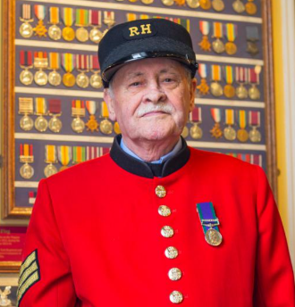
John a seventy – eight-year-old pensioner was our tour guide. We visited different areas of the Hospital including the dining hall, chapel, museum and we had a quick look at one of the corridors where the pensioners had their bedrooms.
The RHC is rooted in traditions; the main one being Founders Day ( also known as Oak Apple Day) on the 29th of May marking both the birthday of King Charles 11 and the anniversary of his restoration to the throne in 1660
It was an interesting visit and very informative.
Carolyn Sekulowicz - Barclay

