National u3a Festival York, 2026 Report, Trevor Ford
Wednesday I went with my sister, Gill for the full 3days of the festival, arriving just in time to miss the opening ceremony with Johnny Ball. However, after a hasty lunch, we joined our first activity, a talk on the hidden messages within the Bayeux tapestry/embroidery, (very relevant on the first day of ticketing for the September exhibition in London; join the queue!)
Later in the afternoon, we split up : me going to a beginners’ class on Mahjong & Gill heading for an open singing session. My class was in an obscure building on the other side of the lake, which was poorly signposted, so it was not entirely surprising that of the 18 participants expected only 11 of us finally made it. Regarding the game, it was a good job that I had played a few times, many years ago, so I was able to guide my table through most of the playing points, though I couldn’t recall the exact method of setting up. Andy, the leader, spent most of his time with the other 2 tables, which particularly annoyed one of our group, who hailed from the Isle of Man. We all enjoyed the colourful spectacle of the tiles with their suits of Circles, Characters & Bamboos, and special tiles : dragons, winds, seasons & flowers. We played open hands initially, then had a proper 2nd game.
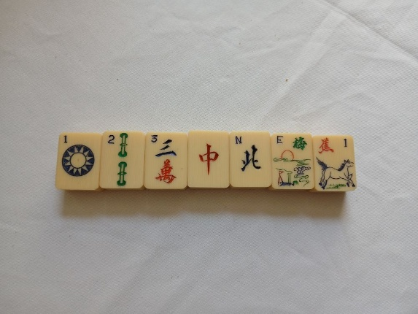
After an evening meal in one of the canteens, we headed off to a performance of “Juke Box Jury”. This was one of the events that I had really enjoyed 2 years before. Excellent fun! The host set up a replica of the old TV programme from the 70’s. After an initial introduction outlining the history of the programme, the main show began. 4 audience members had volunteered to act as the Jury. The rest of the audience were to act as the casting vote of “Hit” or “Miss” as to whether we thought the song would make the Top 10. Even with the wisdom of hindsight there were some surprises as to which category those songs played from the 70’s fitted into. Many of the songs were so well known that the audience sang along (to all the words). That event finished at 9.30 & my sister proclaimed herself so tired she was going straight to bed, but we went via a hall with a Ceilidh band. We couldn’t resist! So recalling our barn-dancing days we joined in. Hot & sweaty after half-an-hour we did retire to our rooms.
Thursday, after a full English (why not? It’s a holiday!), we joined in with a Tai Chi/Quigong session outdoors overlooking the lake. A coffee to revive us, then we both headed off to “Script Reading”. This was great fun. There were 3 scripts (rather than 1 play): a WI scenario, a past radio script about Tony Hancock, and a comedy who-dunnit based around “All Fools & Horses”.
We side-tracked the official arrangements in that afternoon to go to a nearby NT garden, Goddards, owned originally by the Terry’s family (of chocolate fame). The official (u3a) visitors were taken by minibus taxi, but we drove ourselves. Glorious floral borders, a woodland with ponds, and a croquet lawn. We played our own rules and Gill beat me. Of course, we finished up with a cream tea.
Back at the “ranch”, Gill retired to her room, while I went to a talk entitled The Funny side of Writing”. Although an accomplished writer and speaker I didn’t find it very funny. Certainly not his own writing or his method of working, but he did quote some weird anomalies in advertising slogans, etc.
Canteen evening meal, then on to a musical performance given by a group of 6 guitarists called “Don’t Fret”, who played hits (or lesser-known) from the 60’s – 80’s. So most of the audience could join in, even though they only displayed the chorus lines on screen. Certainly my sister had a better memory than me and had a great sing-song.
Friday Breakfast together, then split to our own activities : Mahjong scoring for me. “Painting for Beginners” for Gill. In fact, entirely coincidentally, we’d shared our breakfast table with the leader of that group. So he had inducted her into the intricacies of his technique before she even reached the workshop. Moreover, during the class he kept referring to her effort, whereas she would have preferred to be left alone. Meanwhile, I enjoyed my second opportunity to play the tile-game and to learn more about playing for higher scores (though I’m usually content just to finish a game).
Coffee break enabled us to pick up a packed lunch again, then leave behind the Festival, although many events continued. We had promised ourselves a visit to the Yorkshire Sculpture Park. Gill had been several times, but me, never. So as it’s a long way from London, a worthwhile chance to view some contemporary and older sculptures in both modern and tradiditonal styles & materials.

