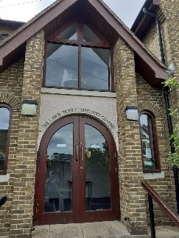
 St.Lawrence Church Hall monthly meetings
Summer Tea Party
& 30th Celebration (belatedly)
 Thursday 21st August
Sidcup Sports Club 2pm
Registration from 1.15pm
Musical Entertainment by Sam Winston
(N.B. Tea or coffee will be provided. The bar will be open to purchase your own additional drinks. This is a members event.)
General Announcements
- Change to Order of Talks for rest of year (List attached)
- Constitution Amended (Attached; Please read; will be voted on in September. Comments to Chair or members of the Committee.)

New on the website this month:-
- Events : Wildlife Photography: report July
- Art Appreciation : Museum Masterpieces Metropolitan Museum of Art’ July
- Architecture/Country Houses : Hardwick Hall, July
- Book Group : review : “The Code of the Woosters” by Wodehouse, July
- Cards : shell/fish cake July
- Quilling : report & photos Poppies, July
- Local History : report & photos : Cartier Jewellery exhibition, July
- Ramblers 2 : report & photos : Kingston to Teddington, July
- Ramblers 3 : report & photos : Cobham, July
Groups Roundup
New Group: Country Houses, Castles & Cathedrals: leader Val Gosden
Using DVDs we can ‘visit’ these places whilst sitting in comfort at home. We will be meeting on the 4th Wednesday of each month, 2-4 pm.
Bridge for Beginners – New English Bridge Union course starting soon
Norman Inniss is an accredited EBU instructor and has given me details of their next local course.
The course is going to start on 6th October and run on Monday afternoons between 2 p.m. and 4 p.m. It is held in the Village Hall in Farnborough Village, which is where Farnborough Bridge Club meets. The course is delivered in blocks of 10, but those with some knowledge of how the game works can, if they wish, miss the first couple. The cost is £10 per lesson, including course material, payable in advance for each block. Most people need about 5 blocks of lessons (spread over 18 months or so) to get to the standard to be able to start playing in a regular club (Farnborough BC have a Tuesday afternoon session for less experienced players).
Why does it take so long? Learning to bid using bidding systems is like learning a foreign language, there is a lot to learn, and you need constant revision. There are literally billions of possible hand distributions, and you need to learn systems that can cope with all possibilities.
Is it worth it? I have to warn you that bridge is very often addictive! In addition, it is an opportunity to meet new people and often forge new friendships. We ran a beginner's course from 2023 to 2024; we had a lot of fun on the way and several of our pupils have made lifelong friends as well as bridge partners. Some of them are playing every day!
Contact Norman Inniss 07525 664304 normaninniss@hotmail.com

Ambers: leaders John Baker & Sheila Donnovan
This month we followed a revised walk which started at Shooters Hill old police station, went up to Severndroog Castle, across to Oxleas Meadows, then down to Eltham Park South. This was a more arduous walk than usual as buses were on diversion around Shooters Hill, not allowing us to start at the top of the hill. We all made it to the cafe at Eltham Park, but the intended visit to Avery Hill was left for another time.'
Art Appreciation: leader Val Gosden
The first two lectures of ‘Museum Masterpieces: the Metropolitan Museum of Art’ focussed on the building of the museum and Greek & Roman Art. Many of the items were sculptures, some being of simple flowing style, whilst others were very detailed. Also shown were decorated ceramic vases and items of jewellery. All were from the period 3,000 BC to 2,000 BC
Country Houses, Castles and Cathedrals: leader Val Gosden
Hardwick Hall in Derbyshire was the subject of our July session. This remarkable Tudor House was owned by Bess of Hardwick, Elizabethan England’s second most powerful woman. The Hall features many large windows, and the letters E S are carved in stone at the high points of the building. Bess of Hardwick married men of note, inheriting after their deaths, making her a very rich woman. Her coat-of-arms are featured in some of the rooms, many of which contain 16th century embroidery, tapestries and portraits.
Family History: leader Kate Berry
Unfortunately, July's meeting was cancelled at the last minute. The Archives at Bexleyheath Library was closed due to roof repairs. Apologies to those who didn't get the message in time! Hopefully we'll be back to normal next month
Handcrafted Card Making: leader Val Gosden
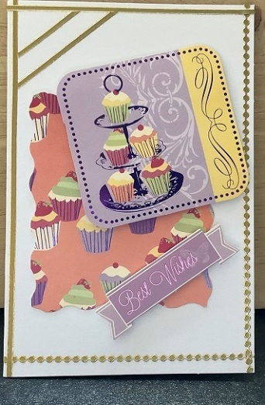  On a hot summer’s day in July, we made two greetings’ cards. One featured marine life helping us to feel a little bit cooler, the other gave us thoughts of a cream tea in the garden. | 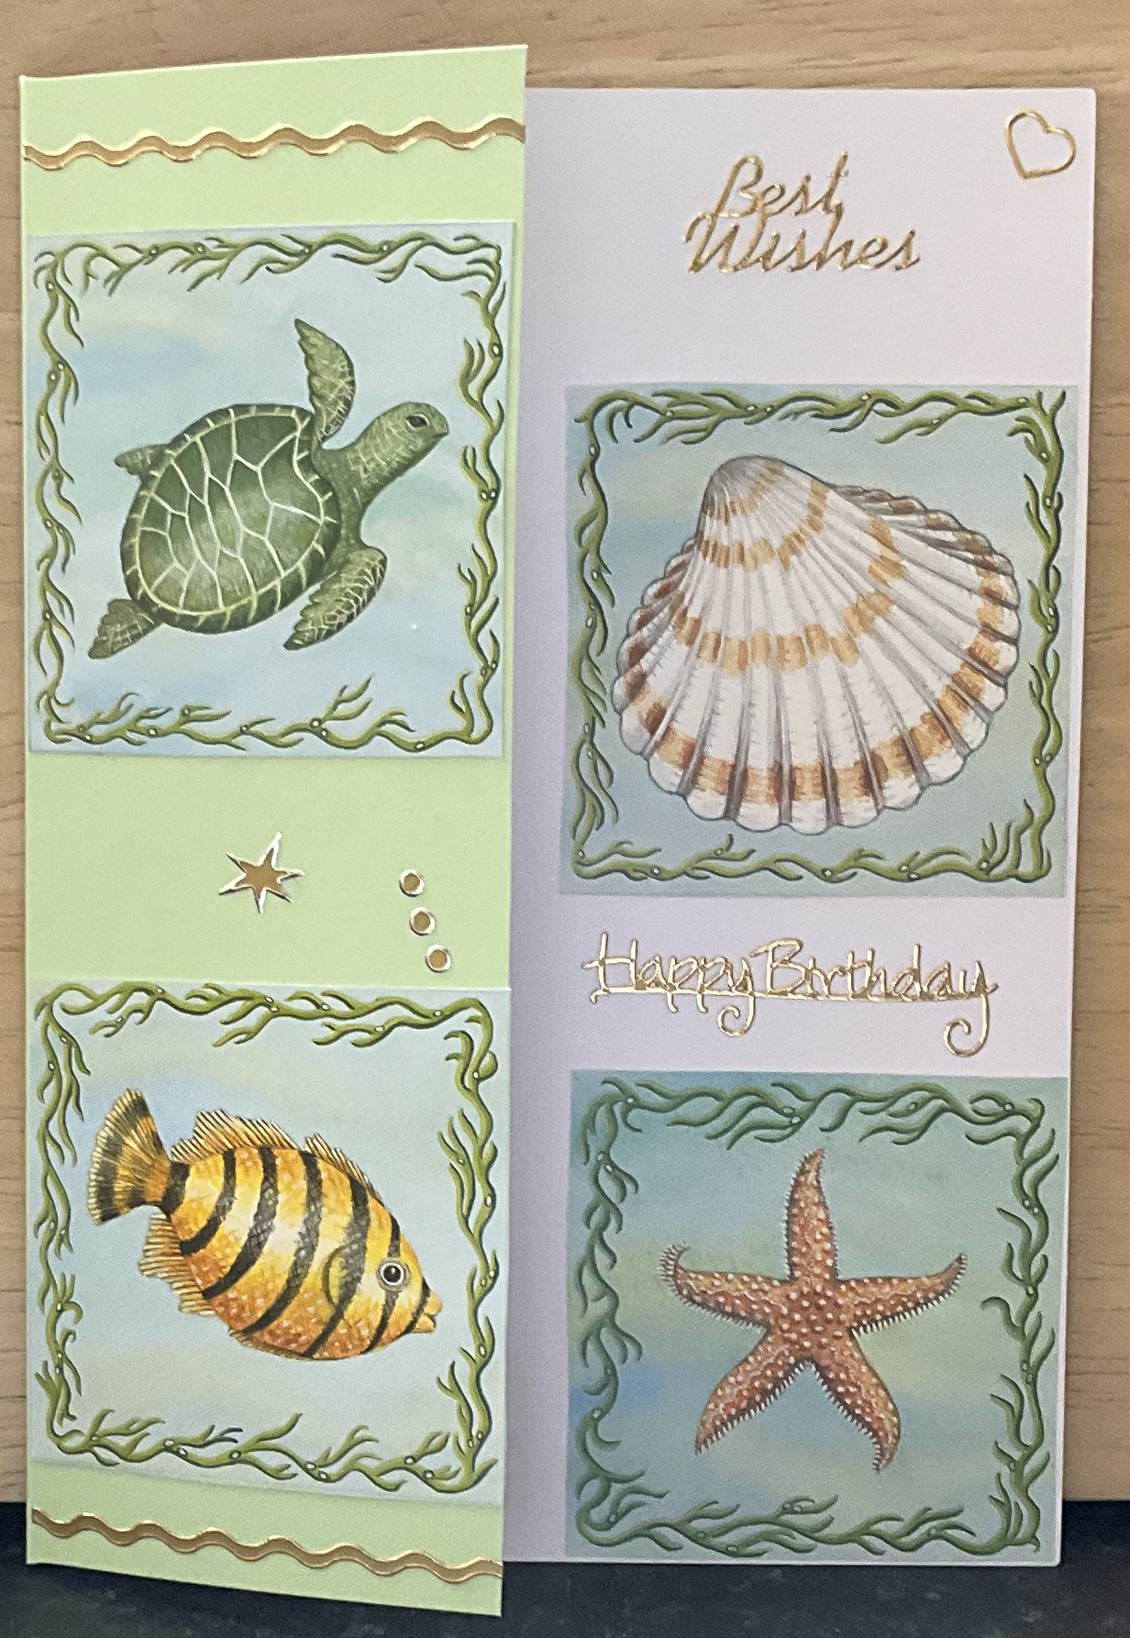

Local History: leader Kate Berry
Jan and I led July's visit to the Cartier Exhibition at the Victoria & Albert Museum.We followed the jeweller and watchmaker Cartier Family through worldwide social changes and technological advances, from 1845 to the present day. Over 350 precious jewels, watches and clocks were displayed. Dazzled and tired we then enjoyed tea and scones in the cafe.
 | 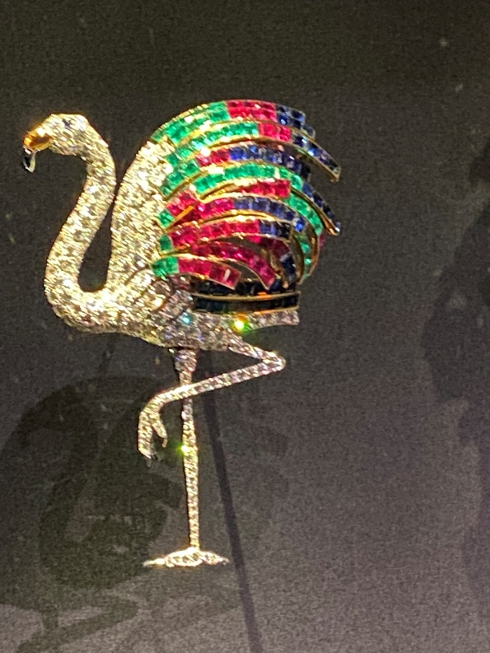

Parks & Gardens: leaders Rinka Halliday and Jill Bryant
The July outing was led by Christine Withams to Valentines Park which is a 52-hectare park, south of Gants Hill, it is the largest green space in the London Borough of Redbridge. The park was originally the grounds of Valentines’ Mansion; a residence built in 1696. Unfortunately, the mansion was not open on the day of our visit.

Pot Pourri: Leader Pat Laughton
Eight members of our group took the train and tube to Sloan Square for a visit to ‘The Flowers’. Flora in Contemporary Art & Culture Exhibition at the Saatchi Gallery in London wherewe explored the many rooms demonstrating the enduring influence of flowers in art, fashion, photography, and design. The exhibition was spread across two floors and nine gallery rooms. It featured over 500 artworks and installations including an interactive digital garden covering the whole wall of one room. It was fascinating.
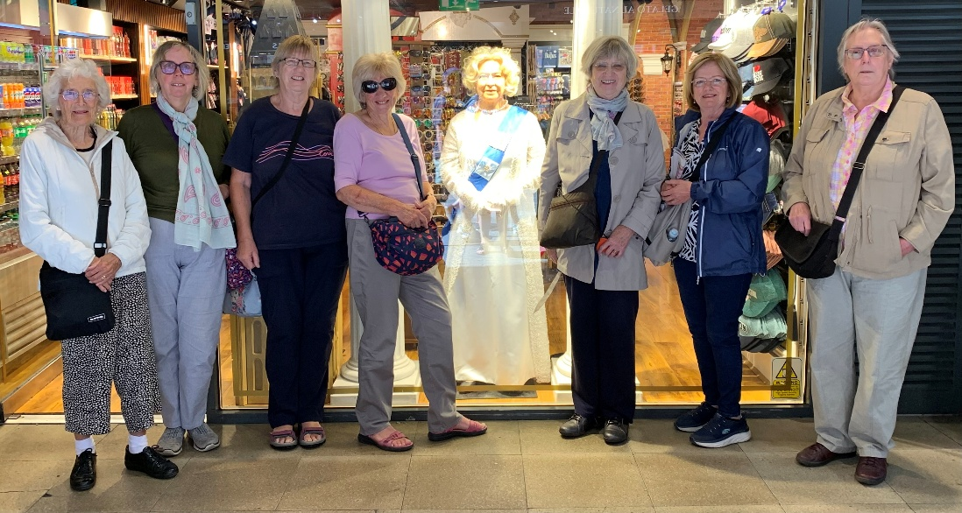

Quilling: Leader Val Gosden

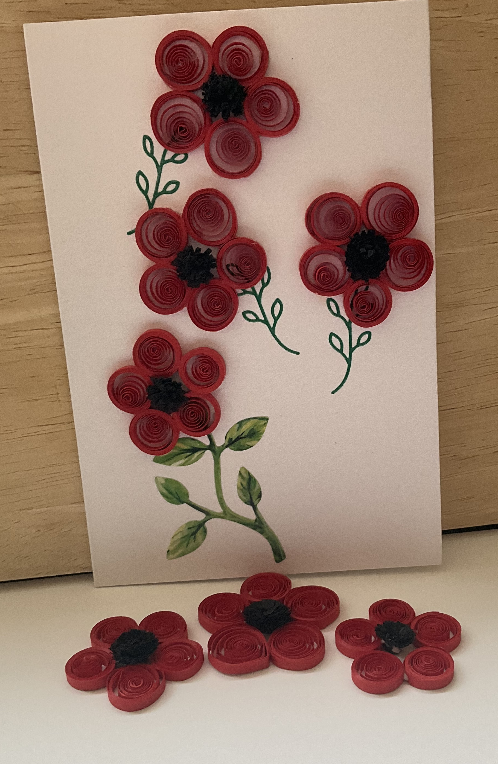 | Quilling  With just a few strips of paper we made these brilliantly red poppies, just adding a few leaves to complete the picture.

Ramblers 2: Leader Helen Salmon
Thames Path from Kingston to Teddington Lock - We joined the Thames Path just before Kingston Railway Bridge, where the river looked very picturesque and finished at Teddington Lock. We took the footbridge across to Teddington where we enjoyed an enjoyable lunch in the Tide End Cottage Pub.
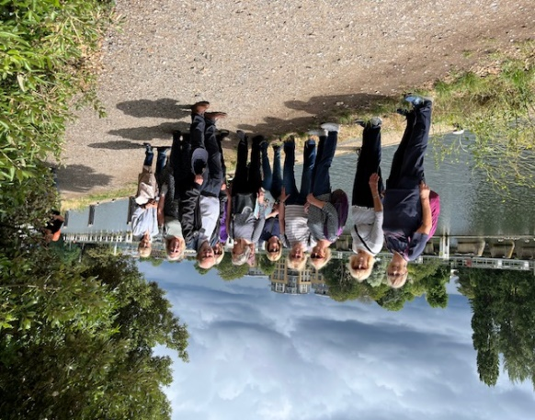

Ramblers3: Leader Trevor

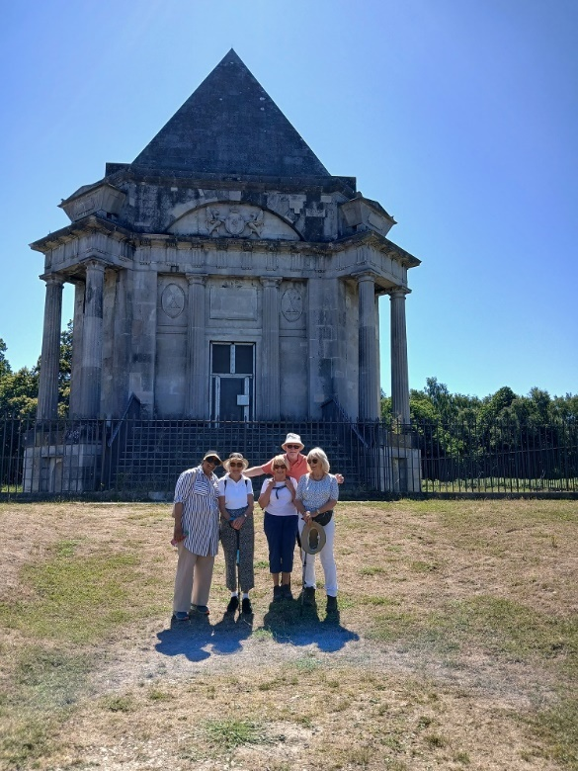
Hot! Hot!HOT! So we shortened our walk & the number of walkers.
We walked from the pub, along Lodge Lane, keeping as far as possible in the shade and made it the 1.5 miles (each way) to the Mausoleum, built by the 3rd Lord Darnley as a family burying place.

National & Regional
- National Friends Newsletter click
- London Region Events, including walks & talks click

