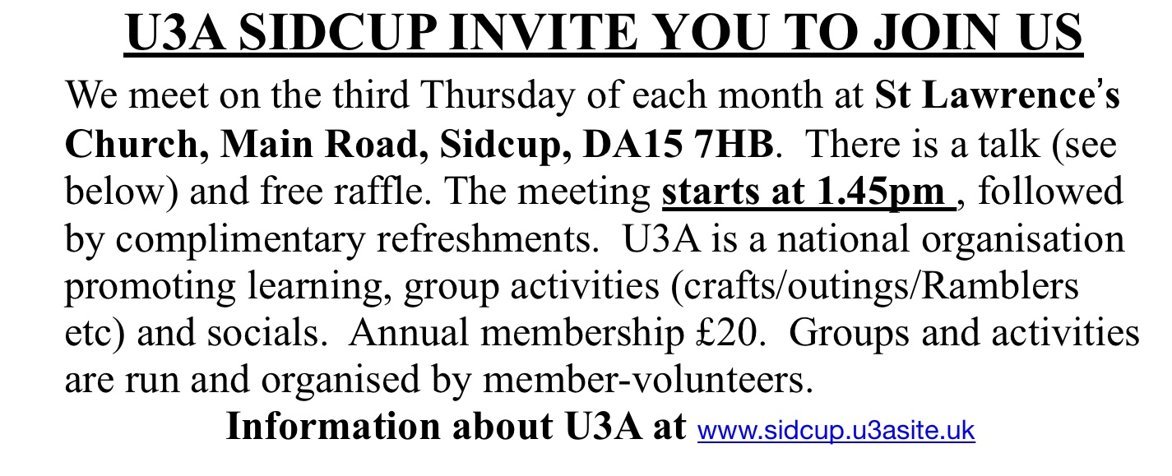
PLEASE BRING A FRIEND…
U3a HAS SO MUCH TO OFFER
THOSE WHO ARE RETIRED

2026 Talks and entertainment
15/1/2026. Christine Davis- Hills of Highgate

19/2/2026 Allan Goodison- The Woodland Trust

19/3/2026 AGM/Membership renewal/2025-6 Photo Celebration

16/4/2026 Jane Scotchmer-Up the Garden Path, Artists and Designers

21/5/2026. Delia Taylor - 80 years of Desert Island discs

18/6/2026. Tony Harris - Shakespeare in costume

16/7/2026. Janie Ramsay - Lifestyle of the Duke and Duchess of Windsor

20/8/2026 Christoph Bull - General Gordon, a man of many titles

17/9/2026 Jay Britton - Summer musical 🎶 entertainment

15/10/2026 Melanie Gibson Barton - Edith Cavell

19/11/2026 Ian Packham - WWII Africa to Italy

17/12/2026 Janette Cantrell- Christmas musical 🎶 entertainment

